**Online Movie Rating Website**

**Name for the website:** Movie Box

**Project Description:** This project is about an online Movie Rating website. We call it the “Movie Box”! In this website we have a signup form for new users and a login form for existing users. The admin can also use the login form to logon to the website. Once the user creates an account with valid credentials, he/she is redirected to the home page. In the home page, a user can see the list of movies, their average ratings and the genre of the movie. A user can filter his/her search based on the genre and also search for a particular movie. Once a user clicks on any movie, he/she can give a rating and write a review to that particular movie. You can also see reviews by previous users for a particular movie. In the *My Profile* section, a user can view the list of movies that he/she had given ratings for. The user can update his/her rating and review as well. The admin has privileges to add a new movie, edit the movie and delete a movie. Once a movie is deleted, the reviews and ratings of that particular movie are also deleted. The admin has the same look and feel similar to a normal user. The admin can write review for a movie like a typical user. When a user is still logged on, he/she cannot get back to home page without signing out and while a user is on the home page, he/she cannot view the other pages without signing in.

**Database Design:** Name of the database is “imdb”

-- Table structure for table `movies`

CREATE TABLE IF NOT EXISTS `movies` (

`id` int(10) NOT NULL,

`name` text NOT NULL,

`year` int(4) NOT NULL,

`genre` text NOT NULL,

`description` text NOT NULL,

PRIMARY KEY (`id`)

) ENGINE=MyISAM DEFAULT CHARSET=latin1;

-- Table structure for table `user`

CREATE TABLE IF NOT EXISTS `user` (

`username` varchar(20) NOT NULL,

`password` varchar(20) NOT NULL,

`name` varchar(30) NOT NULL,

`email` varchar(30) NOT NULL,

`privileges` varchar(4) NOT NULL,

UNIQUE KEY `username` (`username`),

UNIQUE KEY `email` (`email`)

) ENGINE=InnoDB DEFAULT CHARSET=latin1;

-- Table structure for table `movierating`

CREATE TABLE IF NOT EXISTS `movierating` (

`movieID` int(11) NOT NULL,

`user` varchar(45) NOT NULL,

`review` text NOT NULL,

`rating` int(11) NOT NULL

) ENGINE=InnoDB DEFAULT CHARSET=latin1;

**Languages and frameworks used for implementation:** HTML, CSS, Bootstrap, JavaScript, jQuery, Ajax, server side PHP.

**Screenshots for main functionalities:**

Home page:



Sign-up:

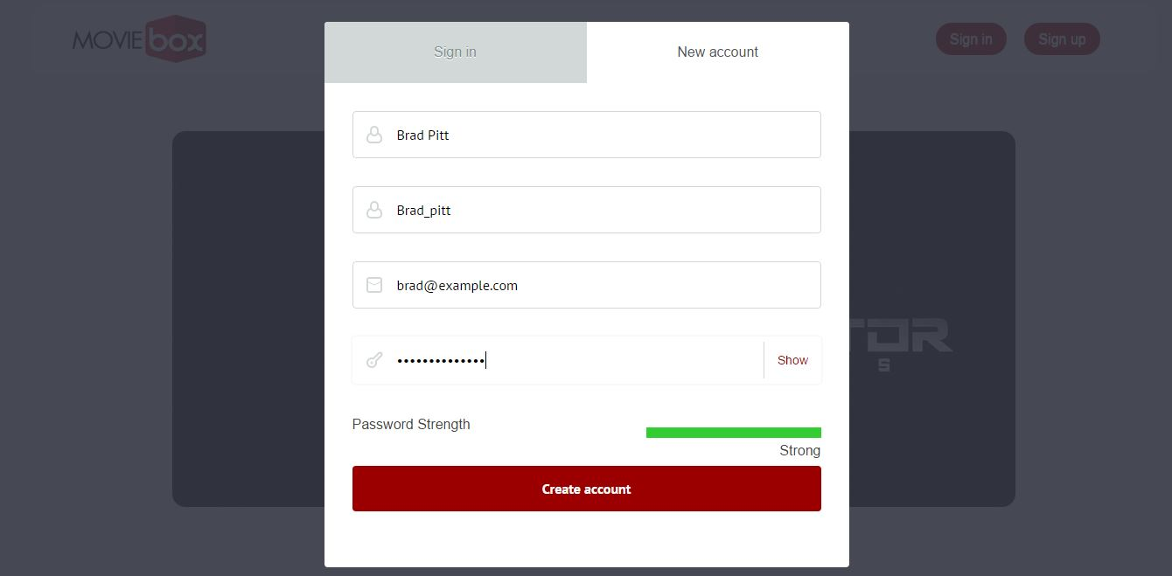

User-home:

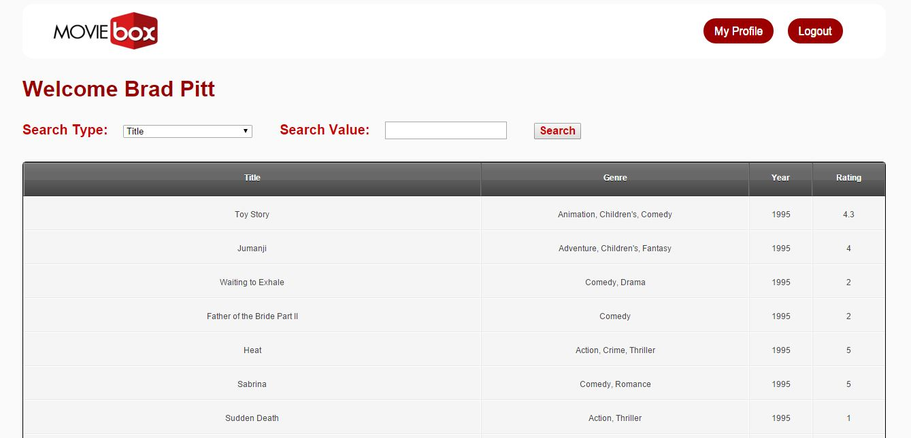

Movie reviews:

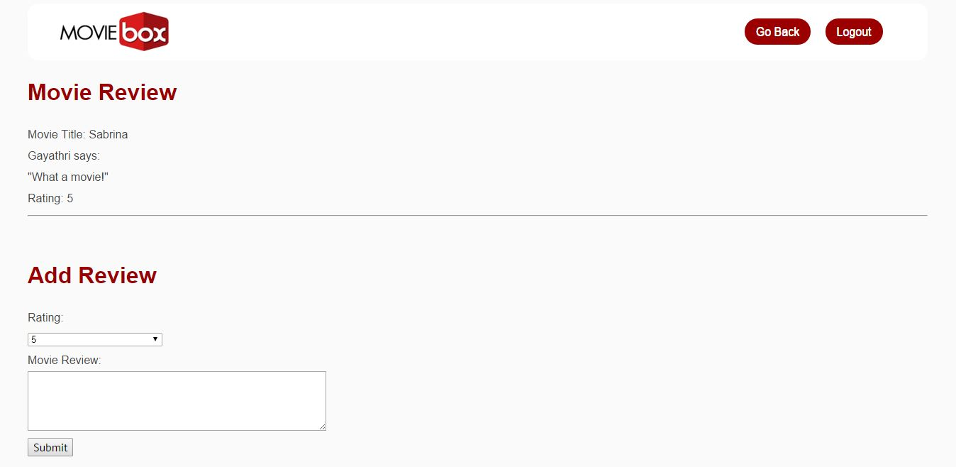

My Profile:

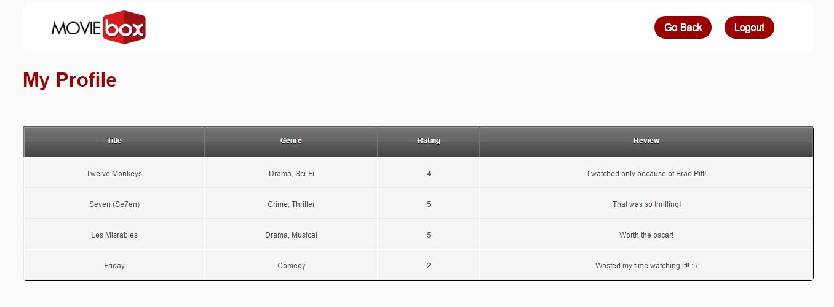

Edit review:

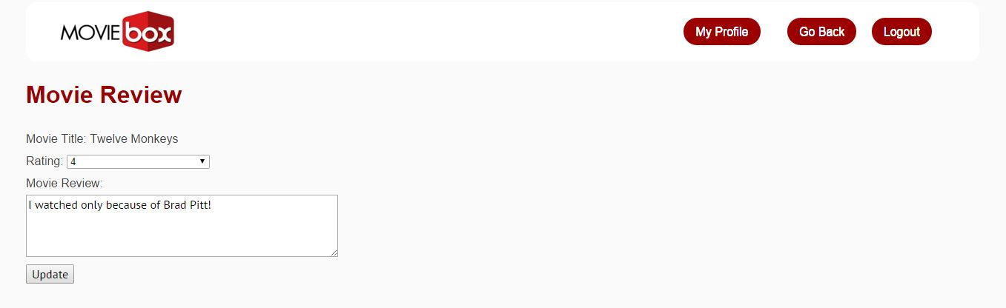

Admin home:

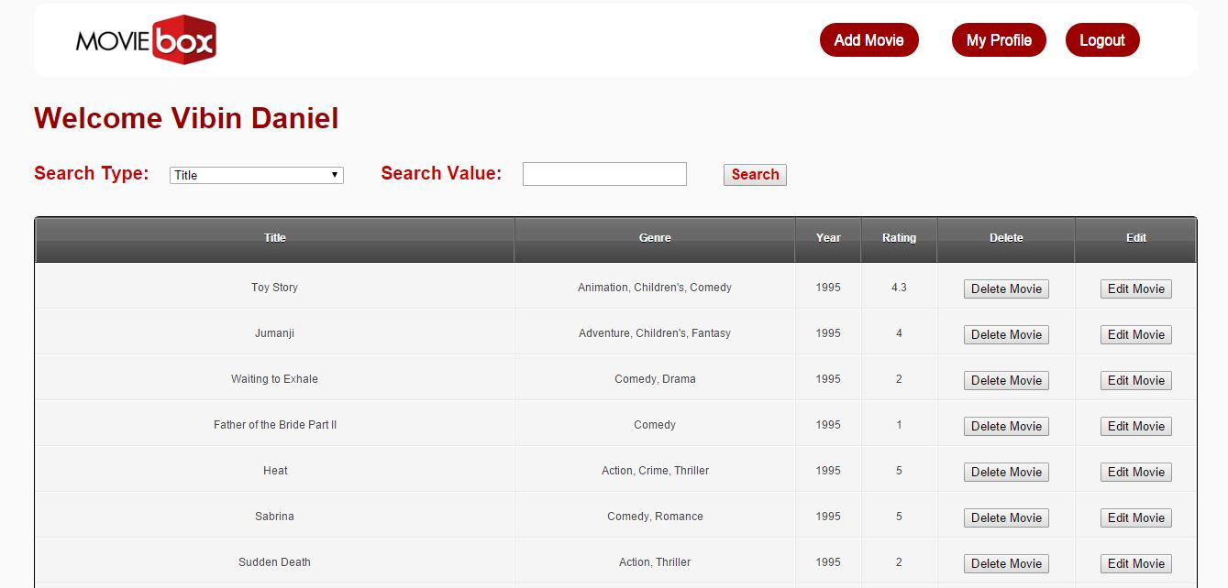

Edit movie:

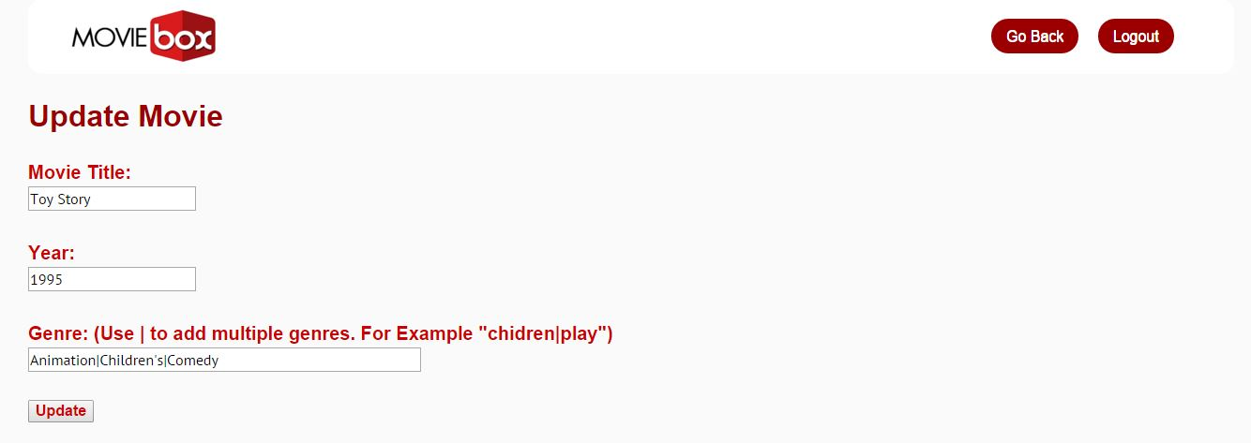

Add movie:

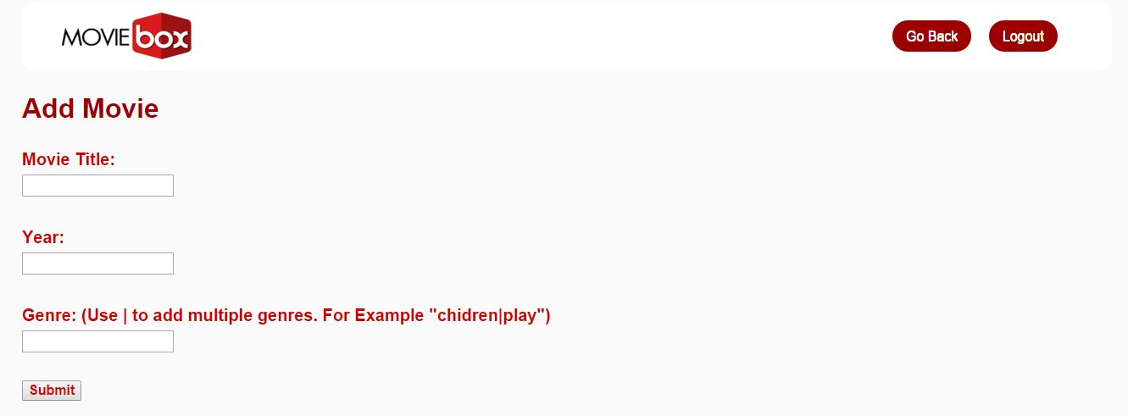

**Team members:**

Gayathri N Kannepalli – gnk140030

Vibin Daniel – vxd141730

Gurleen Chawla – gxc131530

**Work division among members:**

**Gayathri:**

* Created the front end design of the webpage, the home page with login and signup forms using HTML, CSS, Bootstrap and JavaScript.
* Client side scripting – validated the login and signup forms, created a script to check the strength of the password using jQuery.
* Fetched the movies data (title, year, genre and rating) for the database.

**Vibin:**

* Created the database and tables (movies, movierating and user).
* Client side scripting - created scripts for button clicks and used Ajax to send requests and receive responses from database using Php.
* Server side scripting - created Php files for add, edit and delete reviews and movies, created sessions from login to logout.

**Gurleen:**

* Created the user & admin’s home page and my profile pages using HTML and CSS.
* Created movie review and edit review pages using HTML and CSS.
* Created add movie and edit movie pages for admin using HTML and CSS.